Bahria University,

Karachi Campus

LAB EXPERIMENT NO.

12

LIST OF TASKS

|  |  |
| --- | --- |
| TASK NO | OBJECTIVE |
| **01** | Develop a logistic regression model using KNIME that accurately predicts whether a passenger survived the Titanic disaster. The model will be evaluated based on its accuracy, precision. |
| **02** | You are a data analyst working for a healthcare organization, and your task  is to predict the likelihood of diabetes in patients using logistic regression in Python. The goal is to identify high -risk individuals to enable early intervention and better management of diabetes. |
|  |  |

Submitted On:

22-05-2024

(Date: DD/MM/YYYY)

**Task No. 01:** As a data scientist, you are part of a team that aims to analyze the Titanic dataset to predict passenger survival. The dataset includes attributes like class, sex,

age, and fare. Logistic regression is the chosen method because of its suitability for binary classification tasks and its ability to provide interpretable results.

Develop a logistic regression model using KNIME that accurately predicts whether a passenger survived the Titanic disaster. The model will be evaluated based on

its accuracy, precision.

**Solution:**

**Output:**

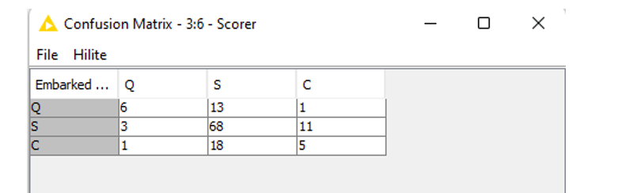

**Task No. 02:** You are a data analyst working for a healthcare organization, and your task

is to predict the likelihood of diabetes in patients using logistic regression in Python. The goal is to identify high -risk individuals to enable early intervention and better management of diabetes.

**Solution:**

import numpy as np

import pandas as pd

from sklearn.datasets import load_diabetes

from sklearn.model_selection import train_test_split

from sklearn.linear_model import LogisticRegression

from sklearn.metrics import accuracy_score, classification_report, confusion_matrix

print(f"Accuracy: {accuracy:.2f}")

print("Confusion Matrix:")

print(conf_matrix)

print("Classification Report:")

print(class_report)

plt.figure(figsize=(8, 6))

sns.heatmap(conf_matrix, annot=True, fmt='d', cmap='Blues', xticklabels=['Below Mean', 'Above Mean'], yticklabels=['Below Mean', 'Above Mean'])

plt.xlabel('Predicted')

plt.ylabel('Actual')

plt.title('Confusion Matrix')

plt.show()

report_df = pd.DataFrame(class_report_dict).transpose()

plt.figure(figsize=(10, 6))

sns.heatmap(report_df.iloc[:-1, :].T, annot=True, cmap='coolwarm', cbar=False)

plt.title('Classification Report')

plt.show()

**Output:**



